Jess Strzempko & Caroline Williams

[JeStrzempko@clarku.edu](mailto:JeStrzempko@clarku.edu) & [CaWilliams@clarku.edu](mailto:CaWilliams@clarku.edu)

Advanced Vector GIS, Fall 2019

12 December 2019

*Examining Climate Change Impacts on Tropical Cyclones*

*in the Western North Pacific using Vector GIS Spatial Analyst Tools*

**I. Abstract**

While a prevalent occurrence in the Western North Pacific (WNP) Basin, tropical cyclones pose a serious threat to communities and ecosystems in East and Southeast Asia with their devastating power. This project seeks to understand how anthropogenic climate change has altered tropical cyclone characteristics and impacts in the Western North Pacific Basin over the past century within the context of human risk and vulnerability. Through the use of IBTrACS (International Best Track Archive for Climate Stewardship) cyclone track data and a variety of spatial analysis tools, changes in storm features over the time period 1917-2016 were explored. This project assesses the developing impact of tropical cyclones on human communities and environments within the study region by examining patterns of changing frequency, direction, concentration, and proximity to populations. Quantifying climatic shifts through the lens of natural disaster impacts allows for the integration of scientific and human-centered perspectives in the final analysis. Results show increasing risk within coastal and island populations, higher storm distribution dispersal, and a northeast shift in cyclone track activity. Further research incorporating wind speed and sea surface temperature data is needed to form a comprehensive understanding of tropical cyclone activity in the region to mitigate future risk.

**II. Introduction**

*Project Objectives*

Our main research objective is to examine the impacts of anthropogenic climate change on tropical cyclones in the Western North Pacific (WNP) Basin within the context of risk and vulnerability. We used ArcGIS software for our study due to the extensive amount of observational data available to analyze tropical cyclones both spatially and temporally. High accessibility to multiple storm track datasets is particularly true in our study region (Ren et al., 2011). Our goal is to find changes in frequency, direction, length, distribution, and proximity to high population density areas resulting from anthropogenic climate change. We will then examine how population risk to these natural disasters has altered as a result of changing cyclone characteristics. This will be accomplished using a variety of spatial analysis and spatial statistics tools provided by ArcGIS software.

*Literature Review*

Tropical cyclones are one of the most severe forms of extreme weather events with the potential to produce destruction and loss across large geographic areas (Sebastian and Behera, 2015). The intensity of tropical cyclones is incredibly difficult to predict due to the complex physical processes involved (Zhong et al., 2018). The Western North Pacific (WNP) has the highest annual number of tropical storms, averaging 35 per year with the ability to cause damage to large coastal populations in Southeast and East Asian countries such as China, the Philippines, Japan, and Korea (Yonekura and Hall Timothy, 2011). This basin experiences intense tropical cyclogenesis primarily due to its high sea surface temperatures (SST) (Yonekura and Hall Timothy, 2011). The WNP basin is a crucial study area for tropical cyclones due to its extent, frequency of storms, and potential risk to large populations. The WNP Basin is further unique when compared to other basins as it is the only basin with year-round tropical cyclone activity (Ren et al., 2011). We chose this basin for our project due to its exceptional characteristics and the unique opportunity it presents to study an area of immense economic, environmental, and cultural importance.

A tropical cyclone is defined by a low-pressure system with wind spiraling inward toward the center (Sebastian and Behera, 2015). Climate change influences on tropical cyclone intensity and frequency is still widely debated in which three major positions have been taken across multiple studies (Ren et al., 2011; Sebastian and Behera, 2015). The researcher may find that intensity has been increasing significantly, decreasing significantly, or neither of the two (Ren et al., 2011). This disagreement regarding tropical cyclone trends further proves the need for accurate research. Several studies have focused on producing models to help predict cyclone activity, while others have utilized observational data, as we will do in this study.

Sebastian and Behera (2015) states that tropical cyclones can be measured through a variety of processes; most notably, the annual frequency, maximum sustained intensity (measured by wind speed), landfall features, duration, and surge height. Some studies have noted a poleward shift in storm tracks alongside increasing intensity and frequency (McDonald, 2011). Due to varying results in previous studies, the need to expand this field of research is necessary in mitigation of climate change impacts. Our research will include a variety of analyses such as the use of kernel-based density products to observe spatial distribution and concentrations of tropical cyclone activity (Joyner and Rohli, 2010; Yonekura and Hall Timothy, 2011). In drawing from previous methodologies to combine with new analyses, we can observe the implications of anthropogenic climate change on tropical cyclones in the WNP Basin.

*Study Area*

Studying the Western North Pacific Basin is of high importance due to the social, economic, cultural, and environmental value associated with the region. With rapidly increasing population along Southeast and East Asian coastlines, this study area is of even greater significance in assessing the human risk of tropical cyclones in a changing climate. This basin is subject to rising sea surface temperatures (SST), resulting from anthropogenic climate change. While other basins are also important to examine, several of them like the North Atlantic Basin have accumulated extensive research unlike the WNP Basin (Joyner and Rohli, 2010; Poulos, 2010). In summary, the WNP Basin is a key study area in tropical cyclone risk assessments. See Figure 2 for a map of the study area.

**III. Data**

See Table 1 for a summary of GIS data layers used in this project. The majority of the data was downloaded from IBTrACS (International Best Track Archive for Climate Stewardship) run by the National Oceanic and Atmospheric Administration’s (NOAA) National Centers for Environmental Information (NCEI), formerly known as the World Data Center for Meteorology. The remaining shapefiles were sourced from ESRI’s open ArcGIS Hub and tutorial files used in Mastering ArcGIS by Maribeth H. Price. All files downloaded were in the geographic coordinate system GCS_WGS_1984 and were projected into the projected coordinate system World Plate Carrée prior to analysis. We used IBTrACS data from 1917 onward as NCEI acknowledges and warns of possible inaccuracies in the earliest data points as a result of the integration of multiple datasets into the full IBTrACS database.

**IV. Methodology**

Analysis began with the use of the select by attribute tool to select point and line data for tropical cyclones that have occurred in the Western North Pacific Basin from the IBTrACS dataset. Next, tropical cyclones were dissolved by serial number so that each separate track was a single polyline with many vertices as opposed to multiple polylines connected at shared vertices. This step was crucial to running the linear directional mean tool as it ensured that the starting and ending points of each cyclone were the only locations considered for analysis (to obtain an overall sense of cyclone path and direction). Finally, select by attribute was again used to select cyclone tracks within each of the 10 decades used for the study. It was desirable to include available cyclone data from the recent years while still working across a long time series, so a full century (1917-2016) was split into 10 decadal time intervals (for example decade 1 is 1917-1926, decade 2 is 1927-1936, and onward). Our reasoning behind the decades not aligning with standard decades of time (for instance 2000-2009) was that cyclones are a natural phenomenon not influenced by human patterns of time.

To obtain major Southeast and East Asian cities that are within the primary path of cyclone destruction, a select by location was used to select cities that are within 250 km of the IBTrACS cyclone tracks. Cyclone diameters range anywhere from 100 to 2000 km during their lifetimes and begin to develop cyclone-force winds around 160 km. Our reasoning was to include cities that may be affected by these strong winds and any other features (like flooding or heavy precipitation) that develop up to a 250 km diameter without assuming that all tropical cyclones develop 2000 km diameters. Next, a summarized distance join with match option of closest was conducted with the major cities within 250 km as the source and the cyclones dissolved by serial number as the destination. At this point, each tropical cyclone was given the name of the city it traveled closest to in the attribute table. This table was then summarized by the major cities column and joined to the major cities shapefile to visualize with graduated colors how many cyclones had traveled closest to it in the last century.

Linear directional mean was utilized to determine the direction and orientation of tropical cyclone tracks for each decade of the overall time interval 1917-2016. The previously dissolved, decadal cyclone tracks layers were used as the parameters of the linear directional mean tool. Linear directional mean was performed 10 times, once for each decade. To visualize the trend in linear directional mean over time, merge was used to create an accumulating effect through the addition of subsequent decade’s linear directional mean results to previous years. Statistical analysis was generated to further study trends in directional mean, mean length of cyclone tracks, and average X and Y points for the genesis coordinates of the cyclone tracks.

In keeping with methodological trends seen in the literature regarding tropical cyclone risk (Joyner and Rohli, 2010), the kernel density tool was used to calculate the density of track observations per decade as a proxy for spatial patterns of risk (Poulos et al., 2010). The cyclone track data dissolved by serial number and selected by decade into 10 different shapefiles was inputted into the tool one by one. Initially, the tool was run with default settings to determine the default search radius (bandwidth) and cell size per decade. The default search radius for all decades was then averaged to obtain new value of 510,168 meters which was used for the final maps. This value ensured that spatial patterns of concentration were not generalized nor over-specified. Cell size was also standardized to 10,000 meters to provide a fine resolution for the maps. Densities were set to be calculated in kilometers of cyclone track per square kilometer and all decades were set to the default extent of decade 6 within the environments settings since it had the largest extent vertically and horizontally. Once the kernel density results were obtained, their palette was set to a stretched tan to red option, transparency was set to 10% to see major landmasses and oceans underneath, and all color values were scaled to the highest track density of 0.147404 kilometers per square kilometer to ensure consistency in visualization of densities across all 10 decades.

Zonal statistics was used to identify population risk from tropical cyclones in recent decades. Both the IBTrACS and Landscan datasets were used. Within the Landscan raster dataset, the years 2000, 2005, 2010, and 2015 were selected for our analysis. Spatial buffers of 500 km were constructed around cyclone tracks using a 5-year temporal “window” around each landscan year. 500km was inputted to reflect the average width of tropical cyclones. 5-year windows comprised around each of the four landscan years had been formulated to account for the recovery time of populations from tropical cyclones. Therefore, for the landscan year 2000 we used the cyclone tracks that occured within the years 1998 to 2002. This logic has been applied to each of the four years to average multiple years of cyclone impact on populations. After creating buffers around these 5-year window cyclone tracks, we performed zonal statistics to calculate the sum of population impacted in each cyclone buffer track. This tool was used to further address the human impact cyclones have over time. The synthesis of a variety of approaches offered ample opportunity to create analytical connections. See Figure 1 for a summary of the project workflow.

**V. Results**

The results derived from the above methods provide a depiction of tropical cyclones in the WNP Basin that we will summarize and interpret using knowledge outside the scope of this paper. Depicted in Figure 3 is the first map produced showing historical risk of exposure to tropical cyclones of major cities in Southeast and East Asia. These results confirm the assumption that communities residing in coastal regions or on islands are at the highest risk of impact by tropical cyclone activity. This can be seen in the location of the cities with the highest risk (quantified as the number of cyclones that traveled closest to this city during 1917-2016): Saipan, Northern Mariana Islands (325); Hagatna, Guam (220); Naha, Japan, (210); and Koror, Palau (210). Tropical cyclones rely on warm ocean water as fuel for their meteorological activity, so it is only logical that the greatest risk and damage to communities would be found on coastlines and islands in the WNP Basin. When a tropical cyclone makes landfall, it can bring flooding and heavy rainfall that subsequently weakens as it travels further inland. These results confirm expectations and provide a framework to interpret the remaining results.

Results for linear directional mean include the temporal changes of linear directional mean, average tropical cyclone track length, and average X and Y genesis points of cyclone tracks. Figures 4 and 5 represent the visual product of linear directional mean by decade while Figures 6 and 7 demonstrate the statistical trends and analysis of changing direction and length in tracks. Linear directional mean from decade 1 to 10 displays a northeastern shift of the degree from due north (Figure 4). There is some variability in the degree of the linear directional mean particularly in decades 6, 8, and 9 (Figure 6), but an overall decreasing trend in the angle further defining the northeastern shift observed visually (Figure 4). In addition to changing direction of cyclone tracks indicated by the linear directional mean over time, track length by decadal averages has also been increasing with time (Figure 7) which explains the shift in start points of cyclone tracks indicated in Figures 8 and 9. These figures display trends in average X and Y starting points in LDM by decade. Visually the starting coordinates of each linear directional mean move to lower latitudes with each subsequent decade (Figure 4). The average X of each starting track point per decade has been increasing, while the average Y has been decreasing (Figures 8 and 9). Average X trends demonstrate the eastern shift in longitude meanwhile the average Y trends exhibit the southern shift in latitude. These results suggest that the direction of storms is changing moving more northward, thus impacting a different populations than from earlier decades. Specifically, China on average was experiencing cyclones directly, however this impact has shifted direction towards North and South Korea. This poleward shift in tropical cyclones corresponds to the results of other studies (McDonald, 2011). The shift in average starting X and Y points and mean length refers to a shift in cyclogenesis, the formation of tropical cyclones in the ocean. The trends in average X and Y and mean length suggest that cyclogenesis is forming at lower latitudes and travelling longer distances perhaps as a result of climate change influences or lack of technology during the collection of earlier data points.

A summary of the results of the kernel density analysis can be found in the animated gif in Figure 10. Figures 11-20 give separate images of each of the 10 decades. These images demonstrate that concentrations of high cyclone activity, designated as having high kilometers of cyclone tracks per square kilometer, are found temporally during decade 5 (1957-1966) and spatially in the South China and Philippine Seas. A possible explanation for the unexpected temporal pattern can be found in the cyclone count by decade (Table 2). Within our study, tropical cyclone occurrences per decade increased up until decade 5, peaked at 441 cyclones, and declined over the second half of the study period. It is reasonable to assume that a year with high cyclone count would show the highest cyclone track density. Figure 7 further supports this finding by demonstrating that the mean length of tropical cyclone tracks increased sharply to just below 4,000 km during decade 5. More frequent, longer storms thus a higher storm density during this time period could have been a delayed result of warming sea surface temperatures caused by the impact of industrial activity during World War II on global atmospheric warming. Additionally, changes in the Interdecadal Pacific Oscillation, a natural climate oscillation, could provide an explanation for presence or absence of activity. The IPO entered a negative phase during 1945-1976 then shifted into a positive phase from 1977-1998. A negative phase brings warmer than average sea surface temperatures to the interior North Pacific while a positive phase reverses this pattern, which agrees with the findings. Finally, tropical cyclone activity displays increasing dispersal throughout the study decades leading to potential increases in areas impacted by cyclones. Subsequently, these results demonstrate a complex relationship between climate change and tropical cyclones that cannot be fully comprehended through this study’s methods.

Figures 21 through 24 illustrate the zonal statistics of human population impact of tropical cyclone tracks in 2000, 2005, 2010, and 2015 respectively. In 2000, the population impact ranges from 0 to 200,000,000 people. The vertical extent to which tropical cyclones impact populations in 2000 ranges geographically from Southeast Asia towards the southern Russian coastlines. In 2005, the range of population impact increases; the impact varies from 0 to 300,000,000 people. The extent of impact remains similar vertically in 2005, but features greater impact inland than in 2000. In 2010, and 2015, impact by tropical cyclones on humans increases, affecting 0 to 400,000,000 people. The extent in 2010 is similar to 2000 and 2005, but features more of the Russian coastline. In 2015, the impact geographically, is the largest. Most of the eastern Russian coastline in the WNP includes some degree of population impact by tropical cyclones. This variation in extent and population affected is further visualized in a GIF (Figure 25). The range of population impact is growing as the maximum population in the region increases with time (Figure 26). Maximum population increased from 2000 to 2015 displaying a positive correlation illustrated by an R-squared value of 0.9878 (Figure 26). The increasing extent of population impact, particularly northward, suggests that there is increasing variability in cyclone tracks, indicated by the linear directional mean results. This variability is likely the product of changing sea surface temperatures resulting from climate change, natural climate fluctuations, or missing data from earlier decades. The growing magnitude of impact defined by the maximum population affected in each year is the result of increasing population over this time period, which inflates the risk of people to tropical cyclones.

**VI. Conclusion**

To reiterate and outline our findings, coastal and island cities are historically at the greatest risk of suffering negative tropical cyclone impacts. Additionally, cyclone tracks over the past century experienced a northeast shift in direction, increase in track length, and southeast movement of cyclogenesis. These findings suggest that storms will span more of the Western North Pacific Basin across their lifetimes with potential increases in population impact. Results from the kernel density analysis further support this conclusion of increasing dispersal of cyclone activity with concentrations observed in the Philippine and South China Seas during the decade 5 of the study. Lastly, population from 2000 to 2015 has increased across Southeast and East Asia inducing higher tropical cyclone risk to human populations across the region. Limitations in our study stemmed from the complexity and wide scope of the topic, primarily the large geographic extent and need to incorporate various climatic components in interpretation. Next steps with this study would be to integrate tropical cyclone wind speed and sea surface temperature data into the analysis to investigate possible impacts of climate change on storm intensity and climatic conditions. This data combined with findings from other oceanic basins could help mitigate risk through the sharing of best practices in terms of research, disaster prevention, and recovery strategies. As tropical cyclones in the WNP Basin disperse and shift northeast with growing impacts on population, human risk and future vulnerability multiplies. Despite the uncertainty of future conditions, anthropogenic climate change is certain to alter climate dynamics in the WNP Basin in the coming decades. Further research needs to be conducted to understand and combat the threats of these natural disasters.

**VII. Team Effort**

The work accomplished in this project has been divided evenly among the two of us. In our methods we detailed four main components of our analysis: the spatial join, kernel density, linear directional mean, and zonal statistics. These tasks were designated to two per person, in which Jess focused on the spatial join and kernel density and Caroline on linear directional mean and zonal statistics. While tasks were divided, consultation on parameters and results was constant so group members had consistent knowledge of the project. Writing and presentation work was also been divided evenly among these assigned analysis processes. For example, our presentation featured an alternating approach of speaking. Meanwhile with the paper, the Results, Methods, and Conclusion were written together, the Abstract and Data was compiled by Jess, and the Introduction (with project objectives, literature review, and study area) was written by Caroline. This approach to the work allowed an even contribution towards the writing, presentation, and methods contributing to a fair, even effort as a research team.

**VII. Figures and Tables**

Table 1. Summary of GIS data layers used in project.

| **Data Layers** | **Source** | **Format** | **Description** |
| --- | --- | --- | --- |
| Tropical cyclone track data 1842-2017 | World Data Center for Meteorology (NOAA-NCEI) | Vector (line) | Line shapefile of global tropical cyclone track data from IBTrACS (International Best Track Archive for Climate Stewardship). |
| Tropical cyclone track data 1842-2017 | World Data Center for Meteorology (NOAA-NCEI) | Vector (point) | Point shapefile of global tropical cyclone track data from IBTrACS (International Best Track Archive for Climate Stewardship) with observations made in 6 hour intervals. |
| World country borders 2008 | Mastering ArcGIS mgis data set  (Maribeth H. Price) | Vector (polygon) | Polygon shapefile of worldwide country boundaries with country names, country FIPS, 2007 population, and land area. |
| Major world cities 2018 | ArcGIS Hub  (ESRI) | Vector (point) | Point shapefile of major world cities with country FIPS and 2018 population. |
| Landscan population data | Oak Ridge Laboratory | Raster (1 km x 1 km resolution) | Raster file of ambient population with 1 km x 1 km resolution for the years 2000, 2005, 2010, and 2015. |

Table 2. Tropical Cyclone Count by decade.

| **Decade** | **Years Included** | **Tropical Cyclone Count** |
| --- | --- | --- |
| 1 | 1917-1926 | 221 |
| 2 | 1927-1936 | 246 |
| 3 | 1937-1946 | 301 |
| 4 | 1947-1956 | 391 |
| 5 | 1957-1966 | 441 |
| 6 | 1967-1976 | 433 |
| 7 | 1977-1986 | 360 |
| 8 | 1987-1996 | 397 |
| 9 | 1997-2006 | 319 |
| 10 | 2007-2016 | 284 |

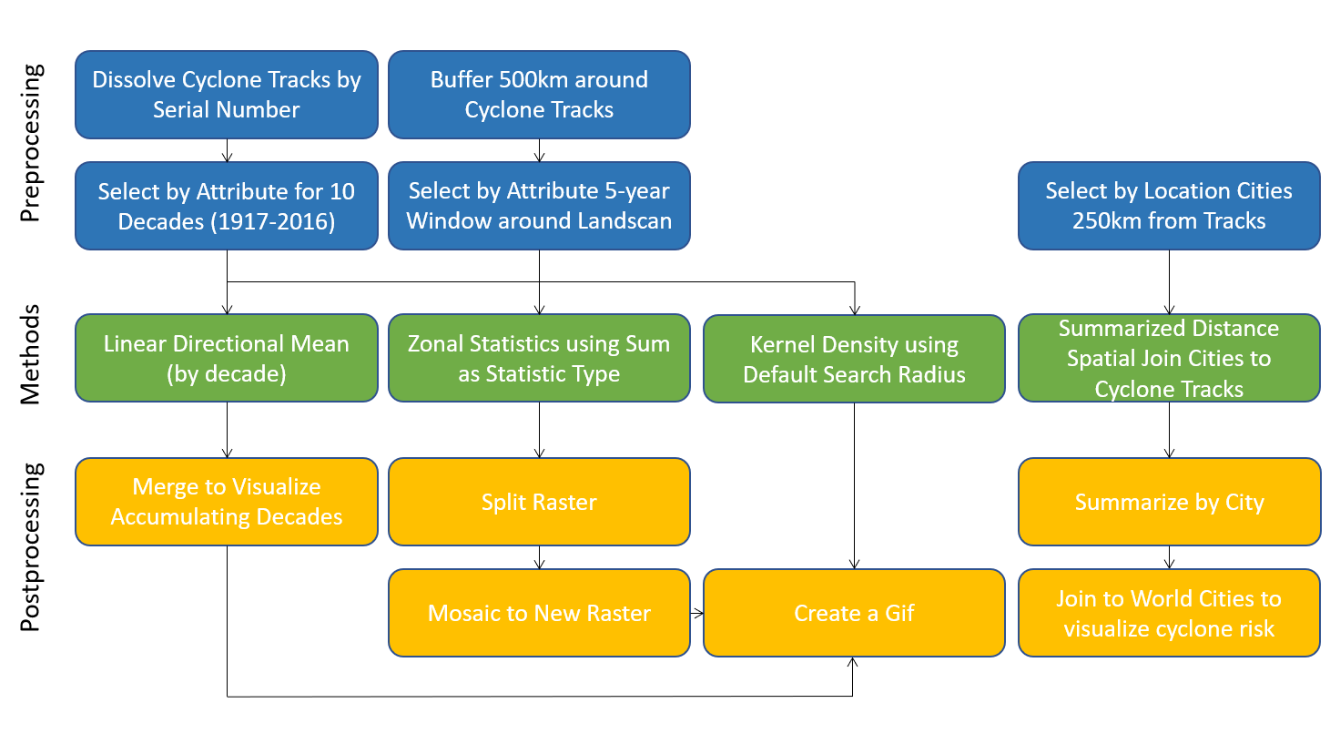

Figure 1. Methodological Workflow of project with steps taken during pre-processing, processing, and post-processing stages.

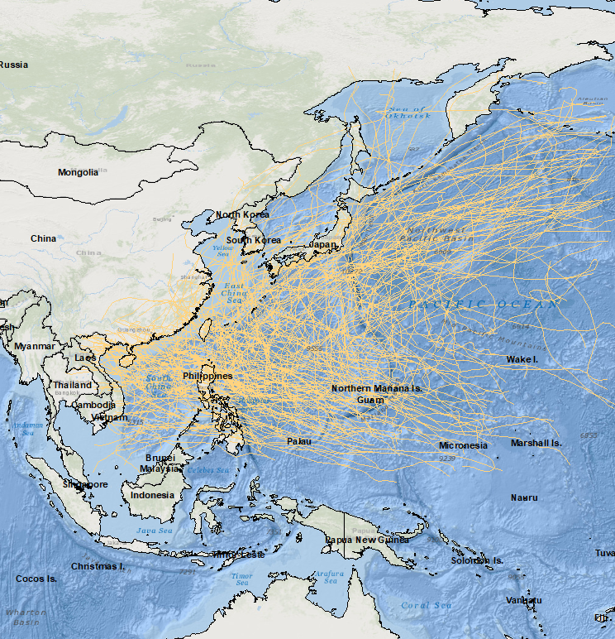

Figure 2. Study Area extent of Western North Pacific Basin overlaid with cyclone tracks for decade 10 (2007-2016) for visuals of unprocessed data.

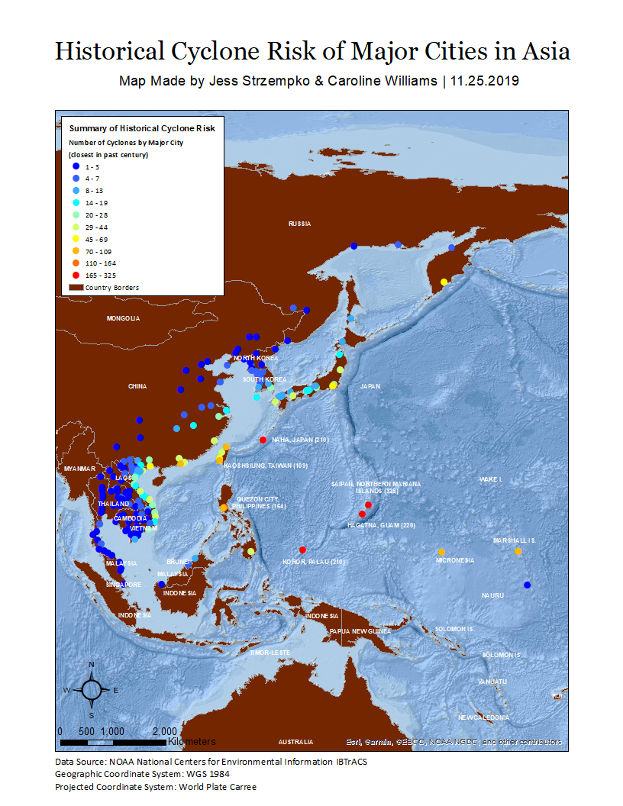

Figure 3. Historical tropical cyclone risk of major cities in Southeast and East Asia.

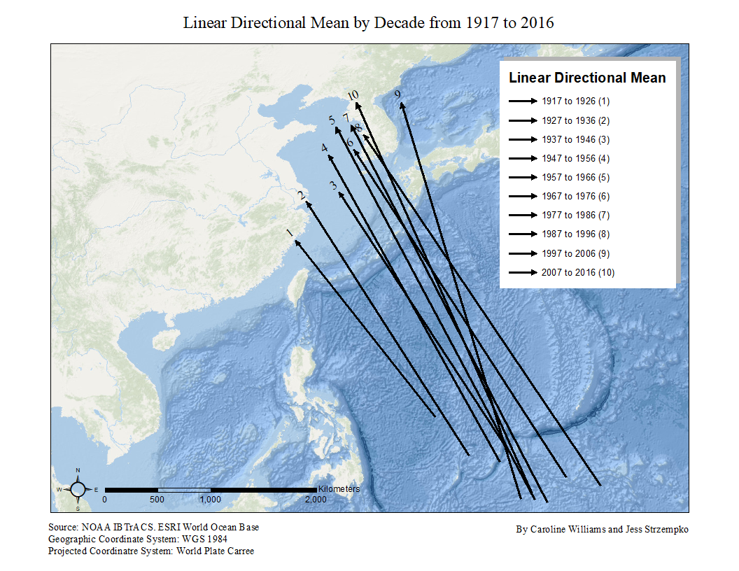

Figure 4. Linear directional mean for the ten decades from 1917 to 2016. Decades are labeled numerically from 1-10 corresponding to the years each represents.



Figure 5. Visualization of linear directional mean over time.

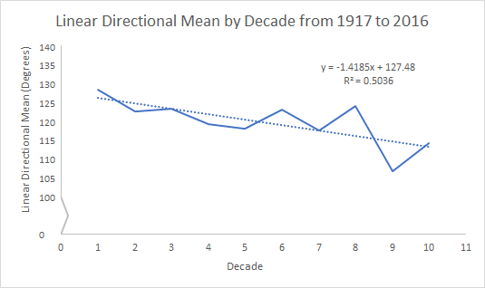

Figure 6. Linear directional mean trendline featuring the change in the degree from due east.

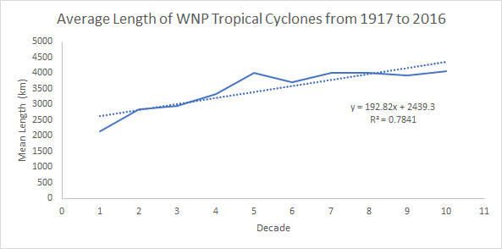

Figure 7. Mean length of tropical cyclones over time by decade.

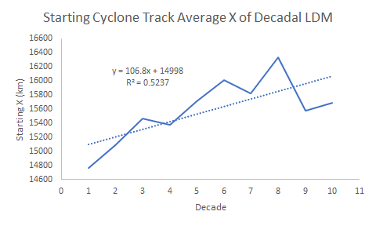

Figure 8. Starting X value of the linear directional mean by decade.

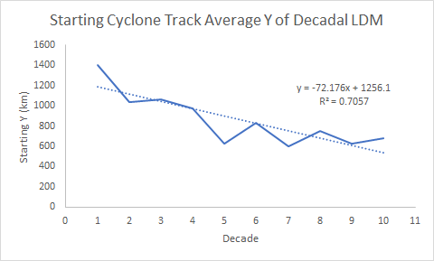

Figure 9. Starting Y value of the linear directional mean by decade.



Figure 10. Visualization of kernel density of cyclone tracks by decades from 1917 to 2016.

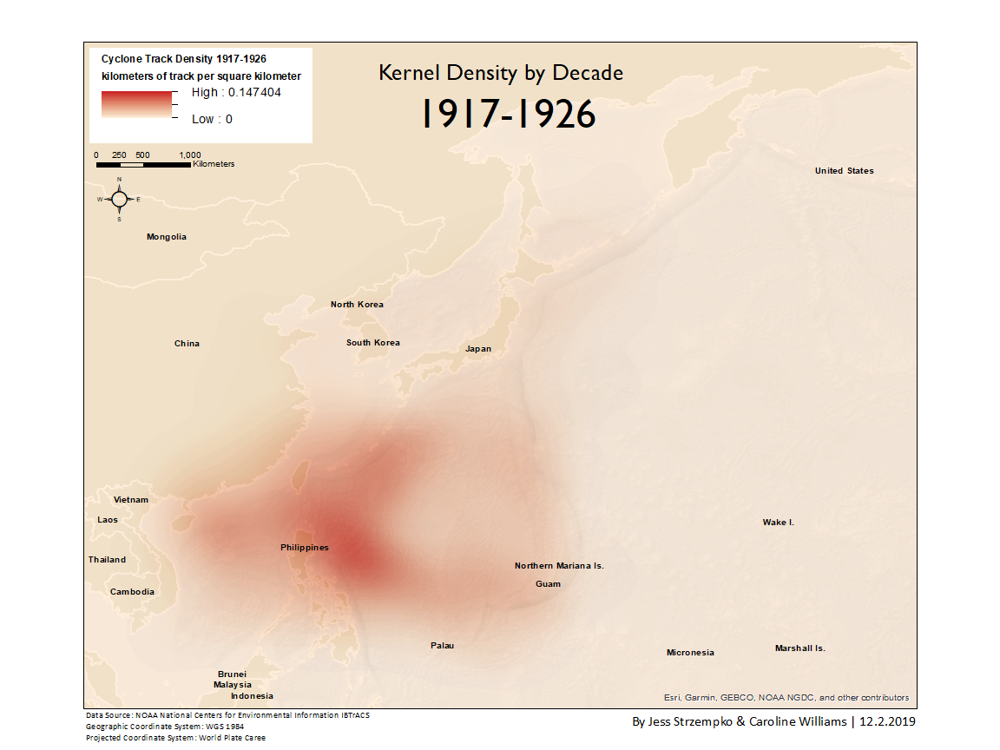

Figure 11. Kernel density of cyclone tracks from 1917 to 1926.

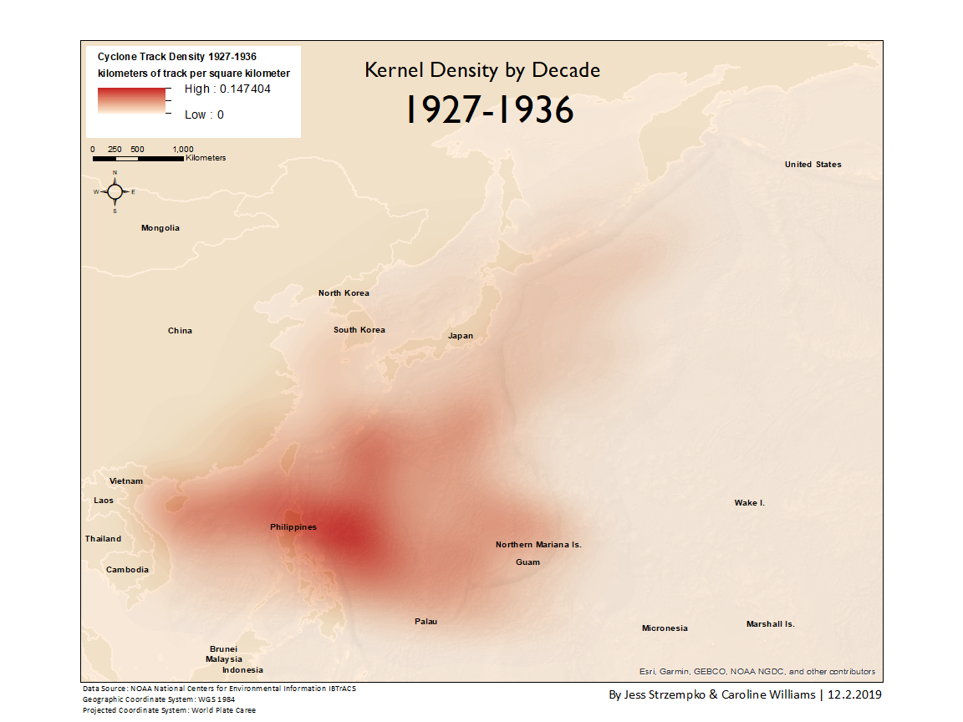

Figure 12. Kernel density of cyclone tracks from 1927 to 1936.

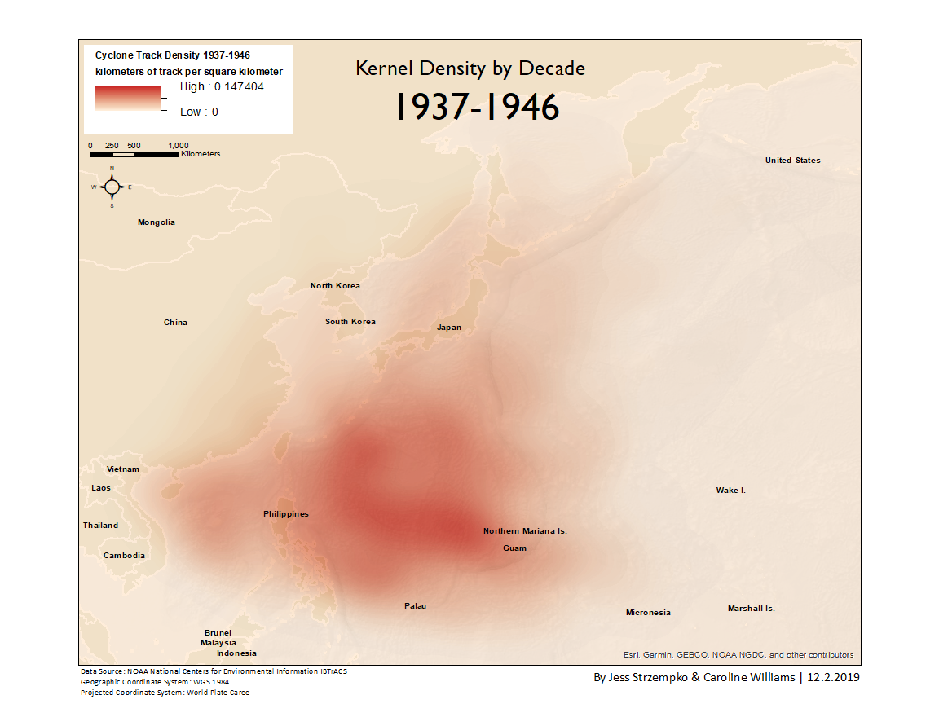

Figure 13. Kernel density of cyclone tracks from 1937 to 1946.

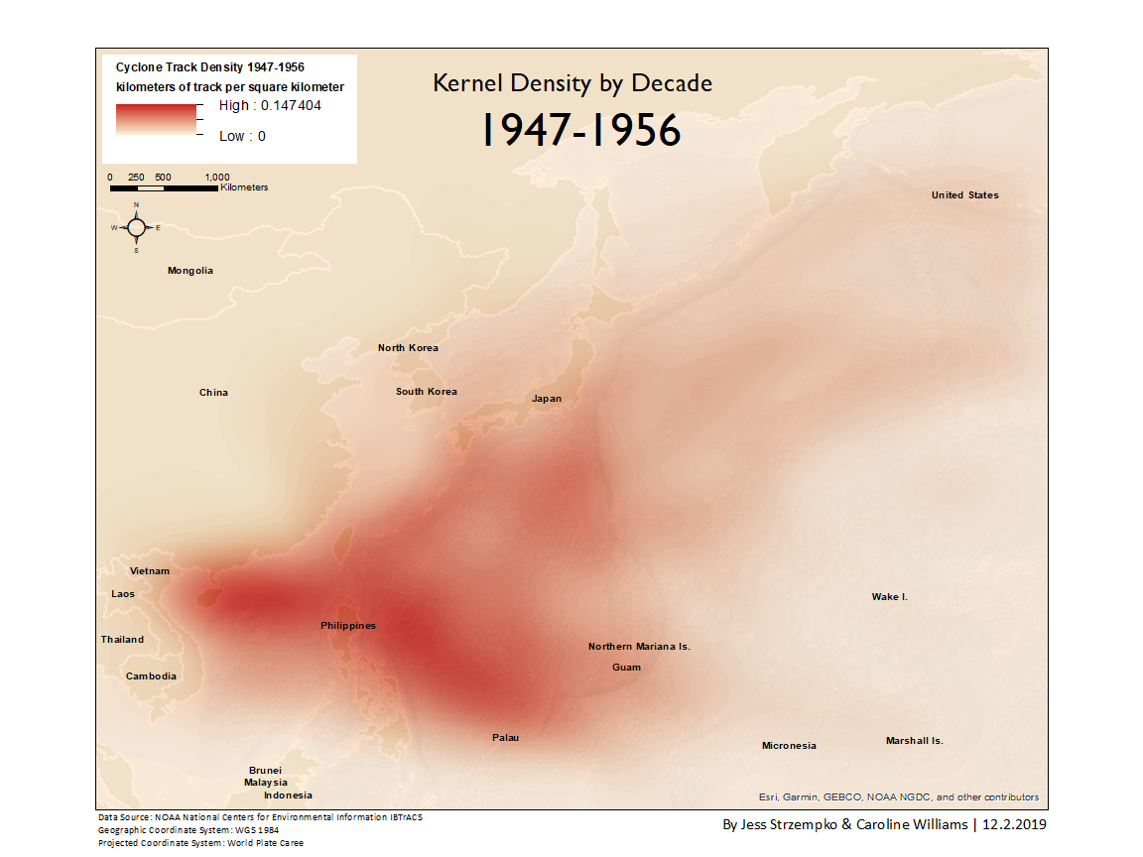

Figure 14. Kernel density of cyclone tracks from 1947 to 1956.

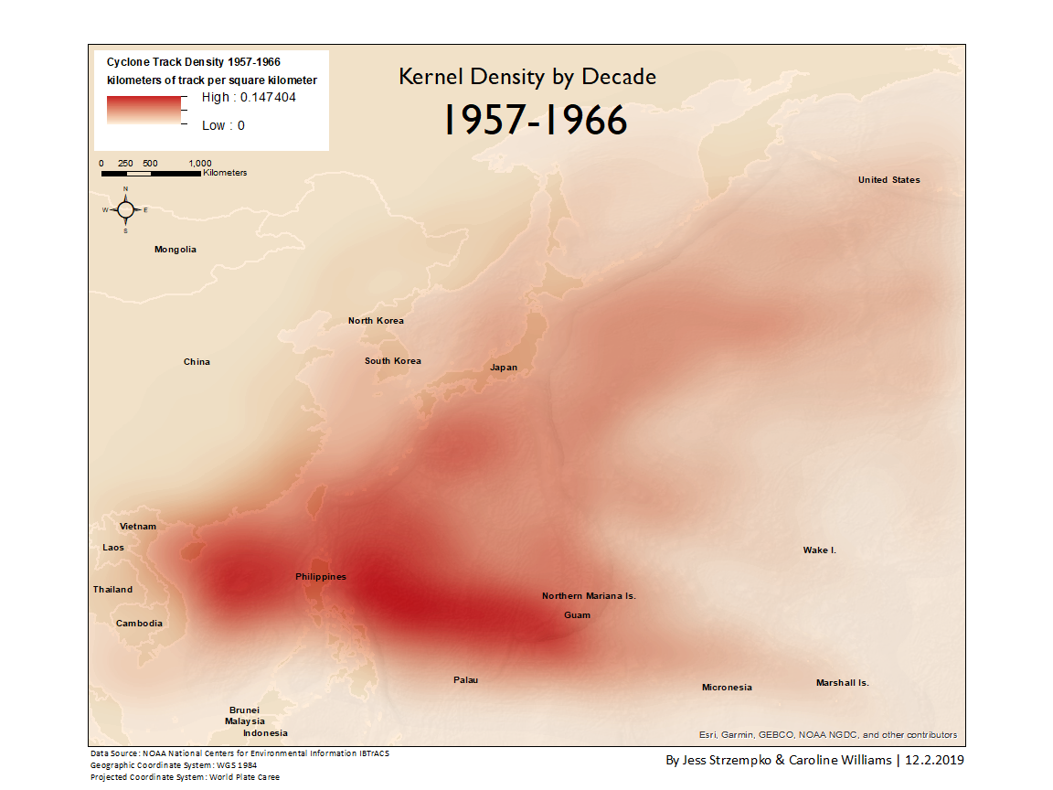

Figure 15. Kernel density of cyclone tracks from 1957 to 1966.

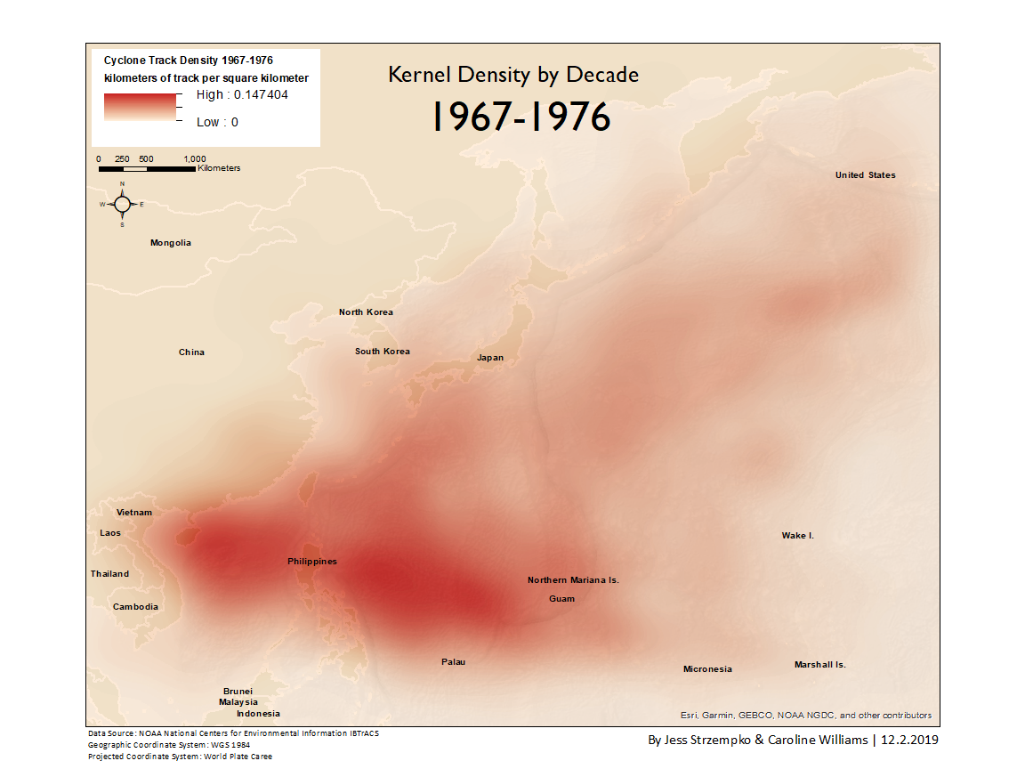

Figure 16. Kernel density of cyclone tracks from 1967 to 1976.

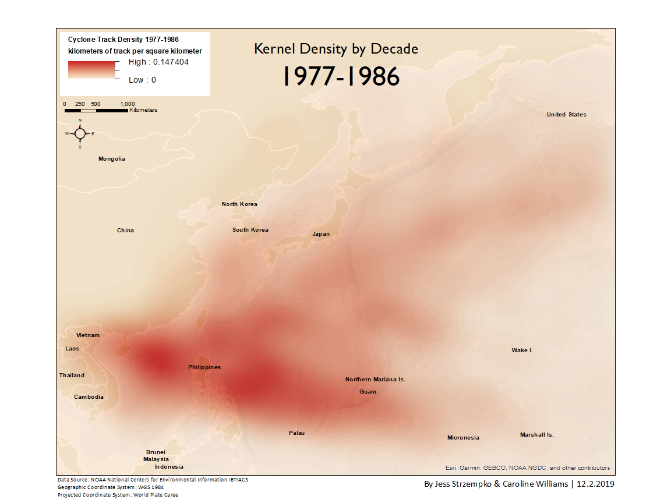

Figure 17. Kernel density of cyclone tracks from 1977 to 1986.

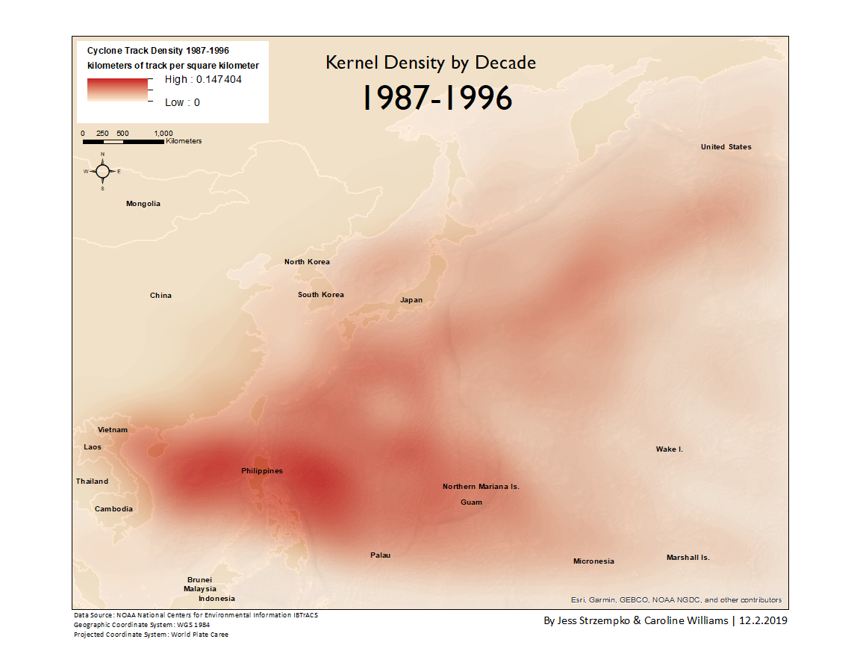

Figure 18. Kernel density of cyclone tracks from 1987 to 1996.

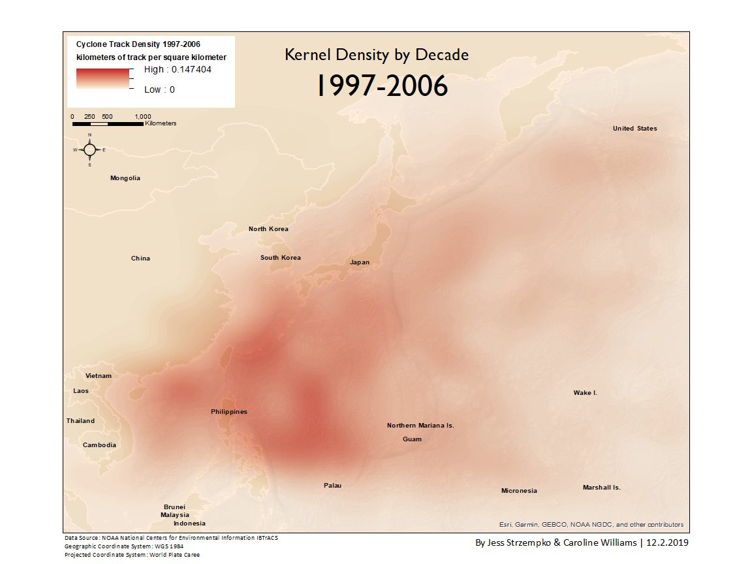

Figure 19. Kernel density of cyclone tracks from 1997 to 2006.

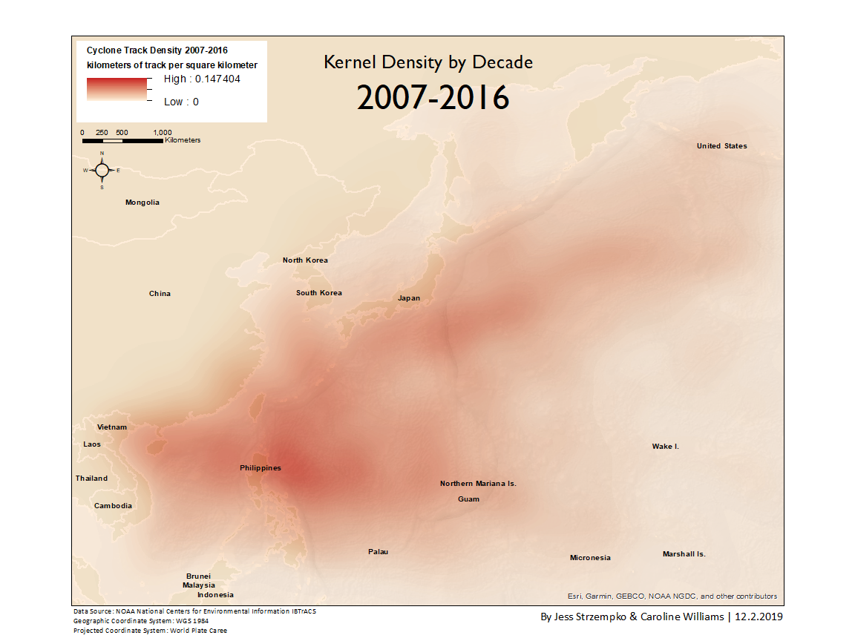

Figure 20. Kernel density of cyclone tracks from 2007 to 2016.

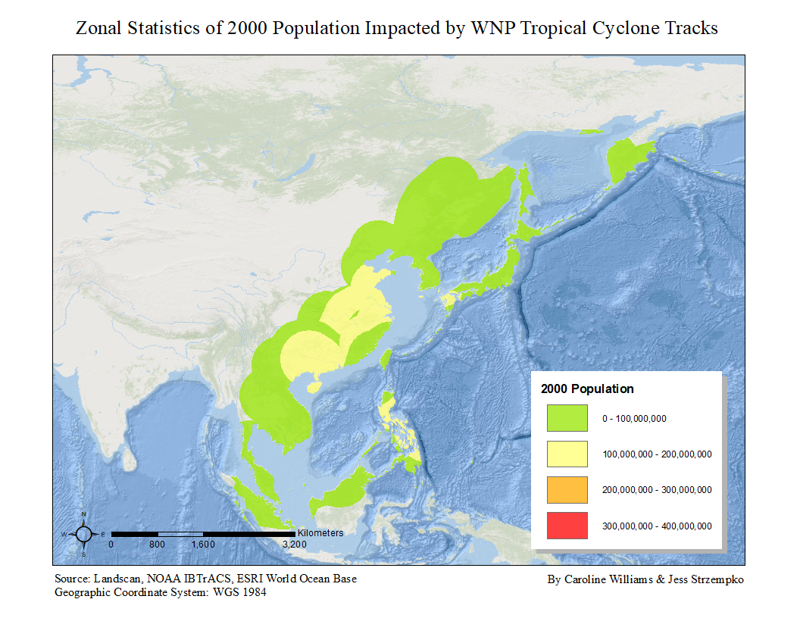

Figure 21. Zonal statistics of population impact by tropical cyclones in 2000.

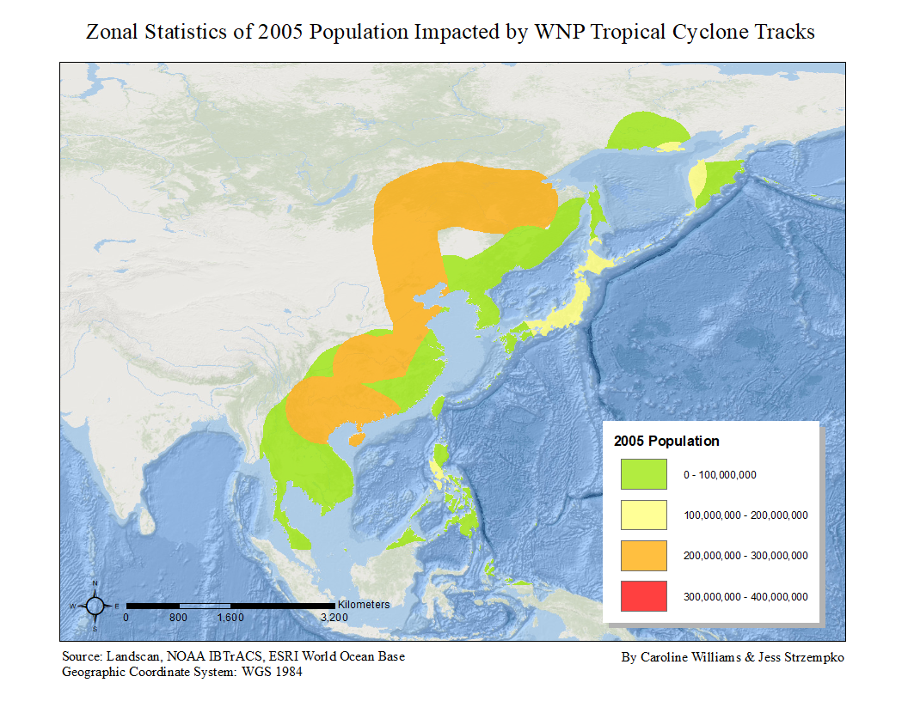

Figure 22. Zonal statistics of population impact by tropical cyclones in 2005.

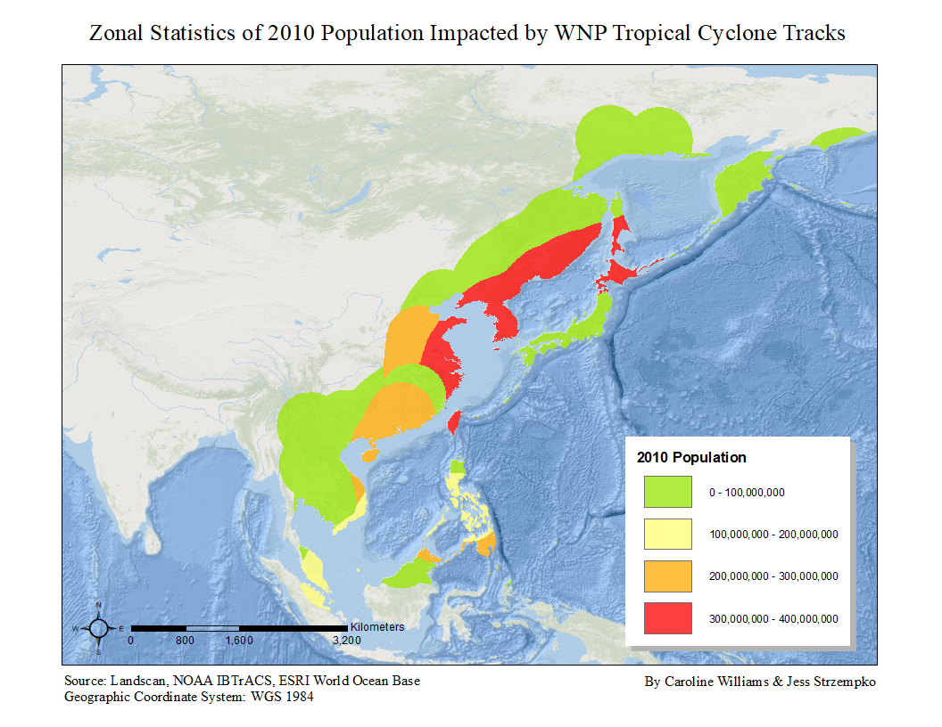

Figure 23. Zonal statistics of population impact by tropical cyclones in 2010.

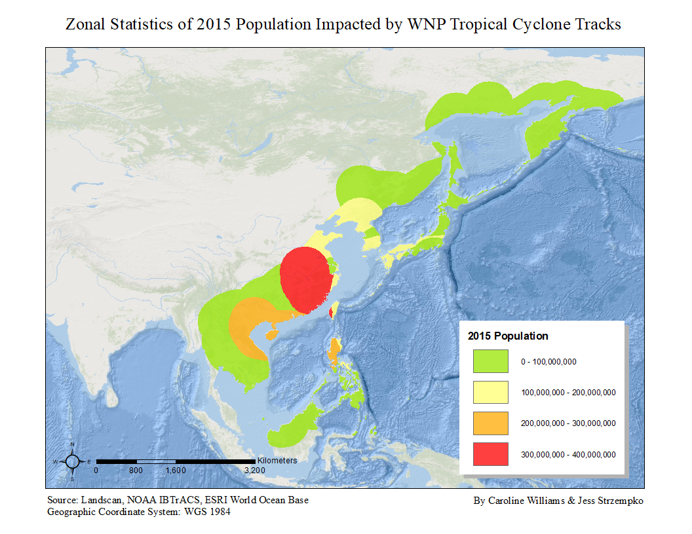

Figure 24. Zonal statistics of population impact by tropical cyclones in 2015.



Figure 25. Visualization of zonal statistics of population impact from tropical cyclones in the WNP in 2000, 2005, 2010, and 2015.

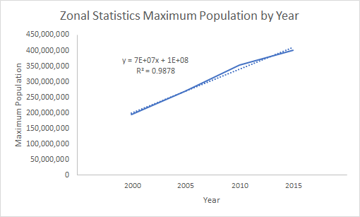

Figure 26. Zonal statistics of maximum population in 2000, 2005, 2010, and 2015 depicting a positive, highly correlated trend.

**VIII. References**

Joyner, T. A., & Rohli, R. V., 2010. Kernel Density Estimation of Tropical Cyclone Frequencies in the North Atlantic Basin. *International Journal of Geosciences*, 01(03), 121–129.

McDonald, R., 2011. Understanding the impact of climate change on Northern Hemisphere extra-tropical cyclones. *Climate Dynamics*, 37(7-8), 1399-1425.

Poulos, H. M., 2010. Spatially explicit mapping of hurricane risk in New England, USA using ArcGIS. *Natural Hazards*, 54(3), 1015–1023.

Ren, F., Liang, J., Wu, G., Dong, W., and Yang, X., 2011. Reliability Analysis of Climate Change of Tropical Cyclone Activity over the Western North Pacific. Journal of Climate, 24(22), 5887.

Sebastian, M. and Behera, M. R., 2015. Impact of SST on Tropical Cyclones in North Indian Ocean. *Procedia Engineering*, 116, 1072-1077.

Yonekura, E. and Hall Timothy, M., 2011. A Statistical Model of Tropical Cyclone Tracks in the Western North Pacific with ENSO-Dependent Cyclogenesis. *Journal of Applied Meteorology and Climatology*, 50(8), 1725.

Zhong, Q., LI, J., Zhang, L., Ding, R. and LI, B., 2018. Predictability of Tropical Cyclone Intensity over the Western North Pacific Using the IBTrACS Dataset. *Monthly Weather Review*, 146(9), 2741.